Milestone 2
Spider Text-to-SQL Dataset: Complete EDA & Profiling Report

1. Introduction
This report documents the complete exploratory data analysis (EDA) and database profiling of the Spider dataset in preparation for a Text-to-SQL pipeline. Spider is the standard benchmark for cross-domain semantic parsing: given a natural language question and a relational database schema, the system must generate an executable SQL query.
Unlike generic database profiling, this analysis focuses on properties that directly affect Text-to-SQL model design: SQL structural complexity, schema linking difficulty, question linguistic patterns, split integrity, and execution-based evaluation feasibility.

2. Objectives
- Acquire and validate the official Spider dataset (train, dev, test)
- Profile all 166 train+dev SQLite databases and extract schema metadata
- Quantify SQL query complexity across all splits
- Analyze natural language question characteristics
- Assess data quality (NULL rates, duplicates, encoding, integrity)
- Generate reproducible profiling reports, charts, and metadata exports
- Document preprocessing and deliver a training-ready dataset package

3. Dataset Identification
Dataset: Spider — A Large-Scale Human-Labeled Dataset for Complex and Cross-Domain Semantic Parsing and Text-to-SQL (Yu et al., EMNLP 2018)
Source: https://yale-lily.github.io/spider | GitHub: https://github.com/taoyds/spider
License: Publicly available for academic and research use.
Task scope: Text-to-SQL only — no dialogue, no multi-turn.

3.1 Comparison with Alternative Datasets
Dataset | Examples | DBs | SQL Complexity | Selected?
Spider | 11,840 | 206 unique | JOINs, subqueries, set ops, nested SQL | Yes
WikiSQL | ~80,000 | 1 table | Single-table SELECT only | No
CoSQL | ~3,000 | 200+ | Multi-turn dialogue | No
BIRD | ~12,751 | 95 | Large DBs + external knowledge | No

Spider was selected because it is the canonical cross-domain Text-to-SQL benchmark with strict unseen-database evaluation splits.

4. Dataset Structure
File / Folder | Role in Text-to-SQL Pipeline | Size
train_spider.json | Primary training pairs (question, SQL, db_id) | 7,000 examples
train_others.json | Supplementary training from 6 legacy datasets | 1,659 examples
dev.json | Validation during model development | 1,034 examples
test.json | Final held-out benchmark | 2,147 examples
tables.json | Schema metadata for train+dev (schema linking input) | 166 DBs
test_tables.json | Schema metadata for test DBs | 206 DBs
database/ | SQLite files to execute queries (train+dev) | 166 folders
test_database/ | SQLite files for test evaluation | 206 folders
*_gold.sql | Flat gold SQL for official evaluation | Tab-separated
schema.json | Exported normalized schema metadata | Generated
database_summary.csv | Per-database profiling report | Generated
column_summary.csv | Per-column profiling report | Generated

5. Text-to-SQL Record Format
Each JSON record is a supervised training example:
Field | Type | Text-to-SQL Role
db_id | string | Selects which database/schema to use
question | string | Natural language input (encoder input)
query | string | Gold SQL output (decoder target)
question_toks | list | Pre-tokenized question
query_toks | list | Pre-tokenized SQL
query_toks_no_value | list | SQL skeleton without literals (schema linking)
sql | dict | Parsed SQL AST (grammar-based models only)

6. Dataset Split Analysis
Critical property: train, dev, and test use completely disjoint database sets (0 overlap). Models are evaluated on unseen schemas, not just unseen questions.
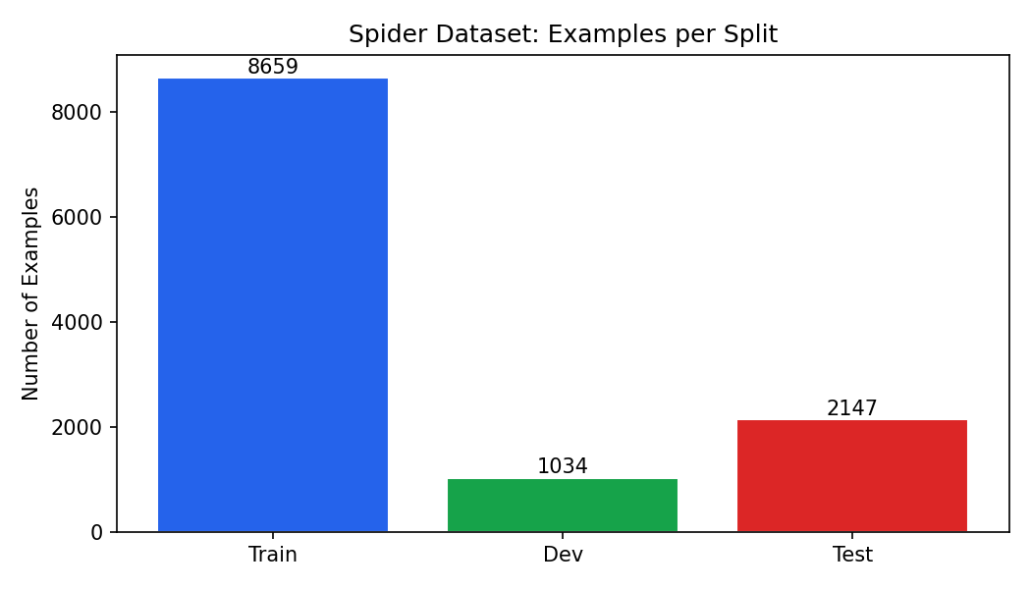
Figure 1: Number of examples per split
Split | Examples | Unique DBs | Avg Q (words) | Avg SQL (tokens) | Unique Pairs
Train (combined) | 8659 | 146 | 12.1 | 18.3 | 8639
Dev | 1034 | 20 | 12.4 | 15.6 | 1034
Test | 2147 | 40 | 12.5 | 16.3 | 2145
Total | 11840 | 206* | — | — | —

*206 unique databases across all splits. Overlap counts: train∩dev=0, train∩test=0, dev∩test=0.

6.1 train_others.json — Legacy Supplement
Six legacy databases (geo, scholar, academic, restaurants, imdb, yelp) add 1659 examples. These have significantly harder SQL: 62.7% JOINs vs 39.6% in train_spider, and average SQL length 28.4 tokens vs 15.9 tokens.

7. SQL Query Complexity Analysis
SQL complexity is the primary difficulty driver for Text-to-SQL. Below is feature prevalence across splits.
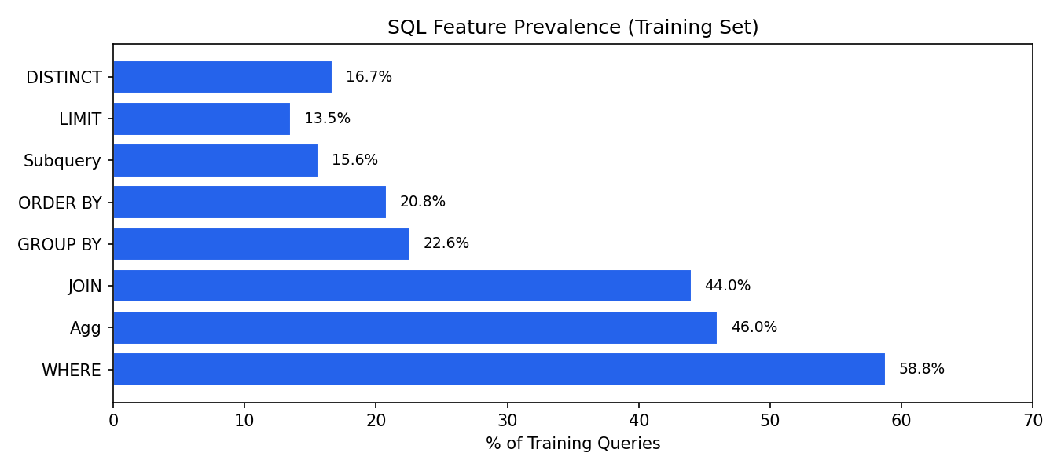
Figure 2: SQL feature prevalence in training queries
SQL Feature | Train % | Dev % | Test %
WHERE clause | 58.8 | 47.7 | 44.3
Aggregation (COUNT/SUM/AVG/MIN/MAX) | 46.0 | 53.3 | 49.3
JOIN | 44.0 | 39.5 | 40.1
GROUP BY | 22.6 | 26.8 | 28.6
ORDER BY | 20.8 | 22.9 | 23.8
Subquery (nested SELECT) | 15.6 | 15.4 | 16.1
LIMIT | 13.5 | 18.3 | 15.6
DISTINCT | 16.7 | 8.4 | 12.6
HAVING | 5.2 | 7.6 | 7.5
LIKE | 2.2 | 1.4 | 2.9
BETWEEN | 0.9 | 0.8 | 0.8
IN (subquery/list) | 4.4 | 4.8 | 4.0
INTERSECT | 2.9 | 3.9 | 3.9
EXCEPT | 2.4 | 3.0 | 3.5
UNION | 0.8 | 1.1 | 1.0

7.1 Aggregation Function Breakdown (Training)
Function | Count
COUNT | 2963
AVG | 547
MAX | 459
SUM | 307
MIN | 255

7.2 Query Complexity Tiers
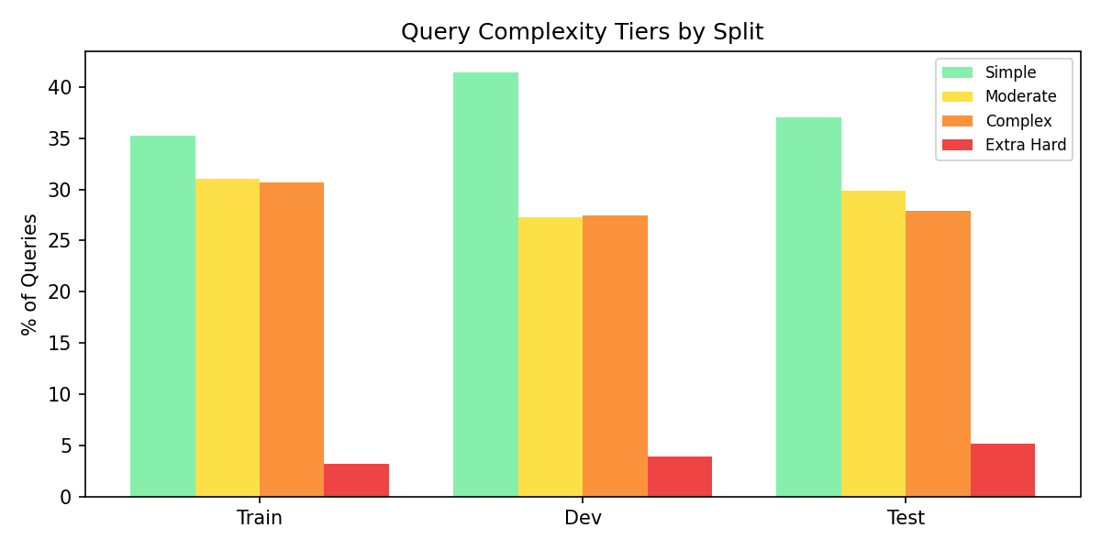
Figure 3: Query complexity tier distribution by split
Tier | Definition | Train | Dev | Test
Simple | Single table, no JOIN/subquery/aggregation | 3044 (35.2%) | 428 (41.4%) | 794 (37.0%)
Moderate | One complex feature | 2685 (31.0%) | 282 (27.3%) | 642 (29.9%)
Complex | 2–3 complex features | 2657 (30.7%) | 284 (27.5%) | 599 (27.9%)
Extra Hard | 4+ complex features | 273 (3.2%) | 40 (3.9%) | 112 (5.2%)

Key finding: ~65% of training queries require multi-table or structurally complex SQL. Schema linking and JOIN prediction are essential.

7.3 JOIN Distribution
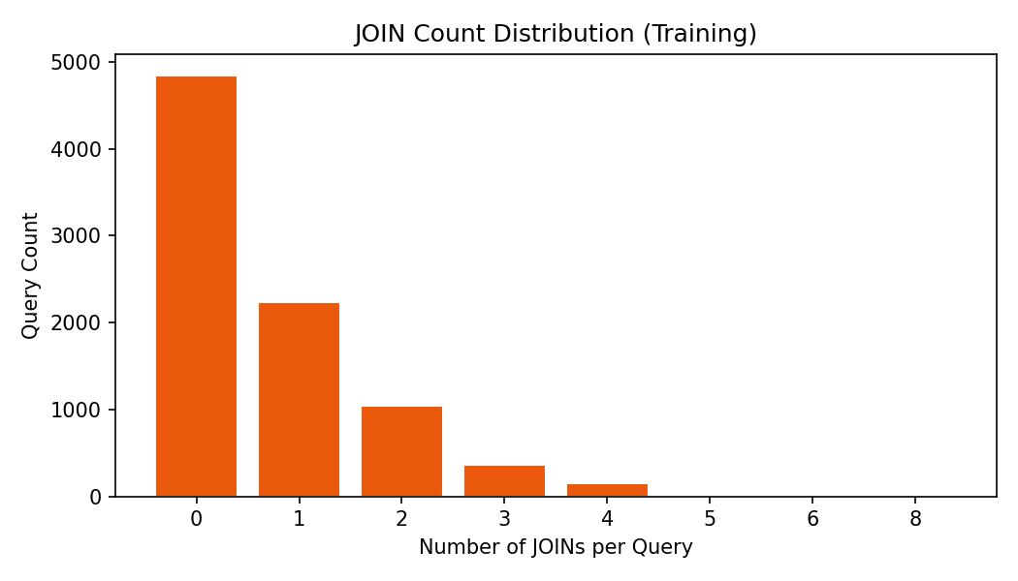
Figure 4: Number of JOINs per training query
Training set: 0 JOINs: 4847 (56%), 1 JOINs: 2233 (26%), 2 JOINs: 1042 (12%), 3 JOINs: 359 (4%), 4 JOINs: 154 (2%), 5 JOINs: 16 (0%), 6 JOINs: 6 (0%), 8 JOINs: 2 (0%).

8. Natural Language Question Analysis
Questions are concise: avg 12.1 words (median 12, range 1–39). SQL targets are longer: avg 18.3 tokens (median 16). This asymmetry means the model must expand/compress semantic intent into structured SQL.
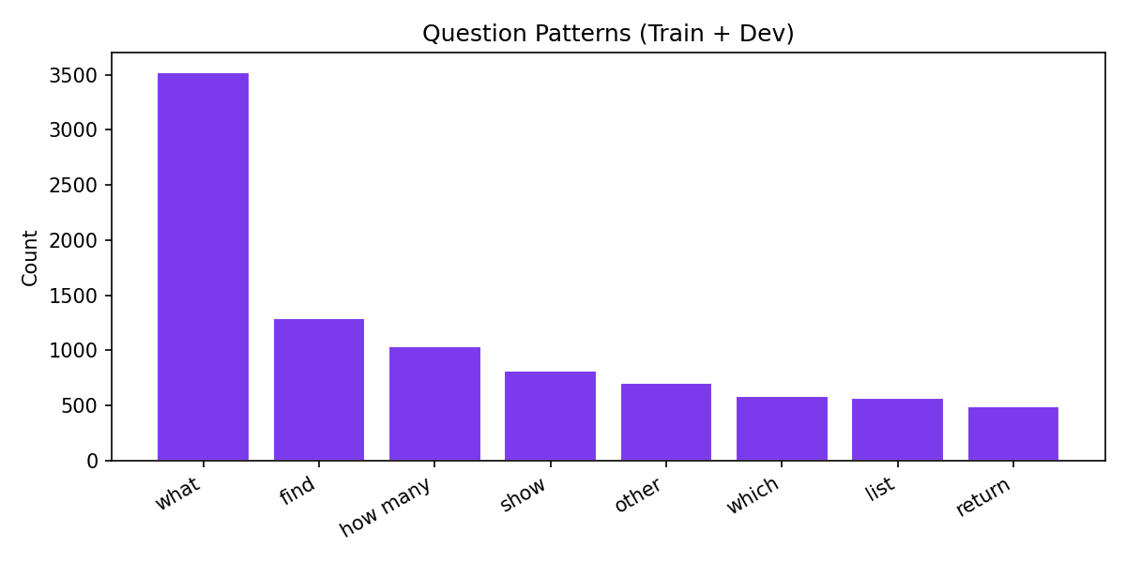
Figure 5: Question type distribution (train + dev)
Pattern | Count | Typical SQL Mapping
what | 3526 | SELECT column(s)
how many | 1039 | SELECT COUNT(*)
find / show / list | 2678 | SELECT with WHERE
which | 588 | SELECT with filter/order
who / when / where | 239 | Entity/attribute lookup
other | 705 | Mixed/complex

9. Database Schema Analysis
Across 166 train+dev schemas: avg 5.28 tables/DB (median 4.0, max 26), avg 27.13 columns/DB (median 19.5, max 352), avg 4.79 foreign keys/DB.
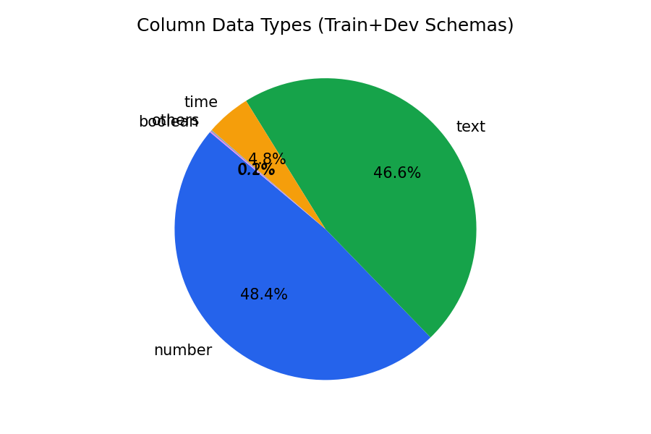
Figure 6: Column data type distribution
Type | Count | %
number | 2178 | 48.4%
text | 2097 | 46.6%
time | 215 | 4.8%
others | 8 | 0.2%
boolean | 5 | 0.1%

9.1 Domain Distribution (Heuristic)
Domain | DB Count
other | 95
business | 22
education | 13
entertainment | 10
transport | 10
sports | 7
geography | 3
food | 3
science | 2
healthcare | 1

10. SQLite Database Profiling
All 166 train+dev databases profiled successfully.
Tables/DB: min 2, max 26, mean 5.3.
Rows/DB: min 0, max 553,693, mean 9,665, median 38.
Columns/DB: min 6, max 352, mean 27.1.
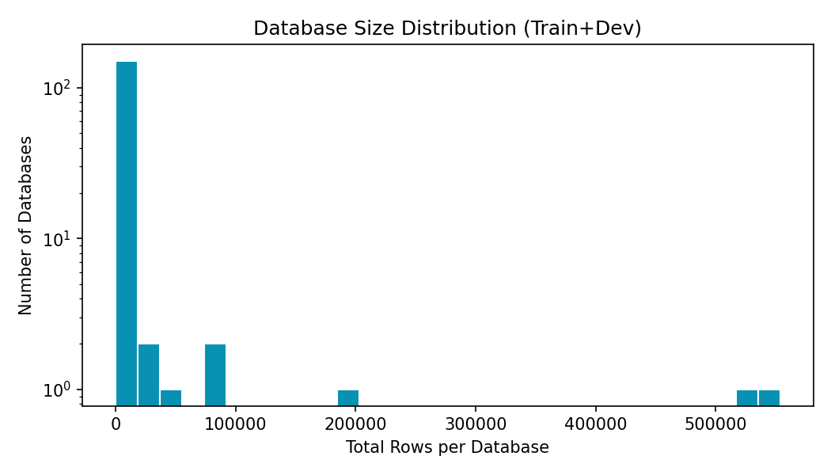
Figure 7: Database row count distribution (log-scaled frequency)
Database | Tables | Rows | Columns | NULL %
baseball_1 | 26 | 553,693 | 352 | 0.0
wta_1 | 3 | 531,377 | 43 | 0.0
soccer_1 | 6 | 196,817 | 84 | 0.62
formula_1 | 13 | 88,380 | 94 | 0.0
flight_4 | 3 | 80,586 | 24 | 8.26

11. Data Quality Assessment
- SQLite integrity: all 166 databases opened and queried without corruption.
- NULL values: mean 1.55% per DB; max 45.55% (cre_Drama_Workshop_Groups).
- Columns with NULLs: 178 of 4503 profiled columns.
- Empty databases: 7 DBs have 0 rows (schema-only, e.g. imdb).
- Duplicate questions: 31 in training; 0 in dev.
- Encoding: all JSON text fields parse cleanly; no unreadable characters detected.
- Annotations: human-verified; 2020 update corrected dev labels and scholar/formula_1 column names.
- No PII: all databases are synthetic or anonymized research data.

12. Sample Text-to-SQL Examples (Dev Set)
Database | Question | Gold SQL | Tier
concert_singer | How many singers do we have? | SELECT count(*) FROM singer | simple
concert_singer | What is the total number of singers? | SELECT count(*) FROM singer | simple
concert_singer | Show name, country, age for all singers ordered by age from ... | SELECT name , country , age FROM singer ORDER BY age DESC | simple
concert_singer | What are the names, countries, and ages for every singer in ... | SELECT name , country , age FROM singer ORDER BY age DESC | simple
concert_singer | What is the average, minimum, and maximum age of all singers... | SELECT avg(age) , min(age) , max(age) FROM singer WHERE country = ... | simple

13. Text-to-SQL Pipeline Design Recommendations
Input format: Serialize schema from tables.json (tables, columns, types, FKs) + natural language question.
Training set: train_spider.json + train_others.json = 8,659 pairs. Never leak test data.
Validation: dev.json — 1,034 examples across 20 completely unseen databases.
Evaluation metric: Execution accuracy: run predicted SQL on .sqlite, compare result sets with gold SQL. Do not use exact string match.
Schema linking: Required for 44% of queries (JOINs). Use query_toks_no_value as auxiliary signal.
Complexity strategy: 65% moderate-to-hard queries. Consider curriculum learning or difficulty-weighted sampling.
Baseline model: Start with schema-aware LLM prompting on dev; then fine-tune seq2seq (T5/BART) if needed.
Error analysis axes: Categorize failures: wrong table, wrong column, missing JOIN, wrong aggregation, syntax error.

14. Preprocessing Completed
- Validated all 166 train+dev SQLite databases
- Extracted schema metadata → schema.json
- Per-database profiling → database_summary.csv
- Per-column profiling (NULLs, cardinality) → column_summary.csv
- SQL complexity classification across all 11,840 examples
- Generated 7 visualization charts → figures/
- Verified zero database overlap across train/dev/test
- Reproducible scripts: eda_spider.py, generate_milestone2_report.py

15. Data Governance
- Source: Official Spider repository (Yale LILY group)
- License: Academic/research use
- Privacy: No PII; synthetic/anonymized databases
- Bias: Uneven domain representation (104/166 DBs in 'other' category); SQL complexity varies by DB
- Reproducibility: All analysis reproducible via generate_milestone2_report.py

16. Deliverables
Deliverable | Description
Milestone 2.docx | This complete EDA report with charts
eda_results.json | Machine-readable full EDA statistics
database_summary.csv | 166 DB profiles: tables, rows, columns, NULL %
column_summary.csv | 4,503 column profiles with cardinality and NULLs
schema.json | Normalized schema metadata for all train+dev DBs
figures/ (7 charts) | Split sizes, SQL complexity, tiers, patterns, types, DB sizes, JOINs
generate_milestone2_report.py | One-command report regeneration script
Original Spider data | JSON splits, SQLite DBs, gold SQL files

17. Planned Activities for Milestone 3
- Implement schema serialization (tables.json → model prompt format)
- Build execution-based evaluator on dev set SQLite databases
- Train/evaluate baseline Text-to-SQL model (LLM prompting or fine-tuned seq2seq)
- Report execution accuracy on dev.json (1,034 examples, 20 DBs)
- Conduct error analysis across failure categories
- Iterate on schema representation and prompting based on errors

18. Summary
This milestone completed a comprehensive Text-to-SQL-focused EDA of the Spider dataset. The dataset contains 11,840 question–SQL pairs across 206 independent SQLite databases with strict cross-domain evaluation splits (zero database overlap). SQL complexity is high: 44.0% JOINs, 15.6% subqueries, and 46.0% aggregations in training. With an average of 5.28 tables and 27.13 columns per database, schema-aware modeling is essential. Data quality is excellent (mean NULL rate 1.55%). All profiling artifacts, charts, and metadata exports are ready for baseline Text-to-SQL model development in Milestone 3.

Appendix: Deep SQL EDA Findings
The following section appends the advanced SQL exploratory analysis performed on the Spider dataset. It extends the milestone with deeper analysis of JOIN behavior, SQL hardness, subqueries, WHERE operators, table relationships, and schema reasoning.
Deep SQL EDA Report
Spider Text-to-SQL — In-Depth SQL Structure Analysis

1. Overview
This report provides an in-depth structural analysis of all 11,840 SQL queries in the Spider dataset. Unlike surface-level counts, we analyze JOIN types, subquery locations, WHERE operators, aggregation patterns, table references, Spider official hardness levels, and correlations between question types and SQL complexity.

2. JOIN Analysis
JOINs are the single most important complexity driver for Text-to-SQL. 44.0% of training queries (3,812/8,659) contain at least one JOIN. 18.2% have 2+ JOINs.
Figure 1: Distribution of JOIN count per query

2.1 JOIN Types
Spider SQL almost exclusively uses implicit INNER JOIN (written as 'JOIN' without INNER/LEFT/RIGHT prefix). No LEFT/RIGHT/CROSS JOINs found in standard splits.
Figure 2: JOIN type breakdown (clause-level)
When a JOIN is present, the average number of JOIN clauses is 1.61. Spider almost never uses LEFT/RIGHT/CROSS JOIN — models can focus on INNER JOIN prediction and foreign key alignment.

2.2 JOIN Rate by Question Pattern
Figure 3: % of queries with JOINs by question type
'Find' and 'which' questions have the highest JOIN rates — they often require multi-table lookups.

2.3 Databases with Highest JOIN Rates

3. Subquery Analysis
15.6% of training queries contain nested SELECT statements. Subqueries are the second major complexity source after JOINs.
Figure 4: Subquery types by SQL location
Most subqueries appear in WHERE clauses (IN subquery, scalar comparison) or as scalar subqueries in SELECT. FROM-clause subqueries (derived tables) are rare (~11 queries).

4. Spider Official SQL Hardness
Figure 5: Spider hardness distribution (training)
Figure 6: Hardness comparison across splits
Spider defines hardness by number of SQL components: SELECT columns, WHERE conditions, GROUP BY columns, JOINs, and nested/set operations. Extra hard queries combine multiple complex features.

5. Table References per Query
Figure 7: Number of tables referenced per query
Single-table queries (1 table referenced) dominate. Multi-table queries (2+ tables) require schema linking — identifying which tables and foreign keys to use.

6. WHERE Clause Analysis
Figure 8: WHERE clause operator frequency
58.8% of queries have WHERE clauses. Average 0.8 conditions per filtered query (median 1).

7. Aggregation Analysis
Figure 9: Aggregation function frequency
46.0% of queries use aggregations. COUNT(*) is the most common (2063 queries). HAVING clauses appear in 5.2% of queries.

8. SELECT Column Analysis

9. Other SQL Clauses
Figure 10: Overall SQL clause prevalence

10. Query Relations Analysis
Query relations describe how tables connect within each SQL query: which tables co-occur, which columns are joined, whether joins follow schema foreign keys, and the topological shape of multi-table queries (chain, star, tree, mesh).

10.1 Relation Topology
Figure 11: Query relation topology distribution
Single-table queries need no relation reasoning. Binary joins connect exactly two tables. Chain joins link tables sequentially (A→B→C). Star joins have one hub table connected to 3+ others. Mesh joins have complex inter-table connectivity.

10.2 Foreign Key Alignment in JOINs
Figure 12: JOIN conditions matching schema FKs
Of 5,877 JOIN column pairs in training queries, 5,210 (88.7%) align with foreign key relationships defined in tables.json. 38.4% of all queries use at least one FK-based JOIN.
High FK alignment confirms that Spider JOINs are semantically meaningful — models should learn to predict joins along schema foreign keys, not arbitrary column pairs.

10.3 Table Co-occurrence & JOIN Patterns
Figure 13: Most frequent table pairs in queries

10.4 Question Pattern → Relation Topology
Figure 14: How question types map to relation shapes
Different question patterns predict different relation topologies. 'How many' questions skew toward single-table COUNT queries, while 'find' and 'who' questions frequently require binary or chain joins across related tables.

10.5 Schema FK Utilization by Database
Exported per-query relation details to query_relations.csv (11,840 rows).

11. Key Takeaways for Text-to-SQL
44% of queries need JOINs — schema linking + FK prediction is mandatory.
All JOINs are effectively INNER JOINs — no need to predict LEFT/RIGHT/CROSS.
88.7% of JOIN column pairs match schema FKs — use tables.json FKs as join supervision.
16% of queries have subqueries — mostly IN-WHERE and scalar comparisons.
COUNT is 5x more common than SUM/AVG — 'how many' questions map predictably.
Hard + Extra Hard queries = ~55% of training set — majority is not simple SELECT.
Question pattern predicts relation topology — use it for few-shot example selection.
Evaluate with execution accuracy — equivalent SQL with different JOIN order should pass.

